College:
information technology

Specialization:
Master's in Multimedia Technology and Web Development

Course:
Advanced Web Computing

Topic Title:
Lab 1 - HTTP/2 vs. HTTP/3

Name:
Ahmed Fawzi Qudaih

University number:
120263981

2026
Objective:
To compare the performance of HTTP/2 and HTTP/3 protocols when loading a multi-resource webpage, measuring the latency of the first byte (TTFB) and page load time under three network conditions: normal, slow, and packet loss. The primary objective is to understand the concepts of multiplexing, head-of-line blocking, and QUIC, and to determine when HTTP/3 is beneficial and when it isnt.
Setup:
-Server: Caddy 2.11.7 on Windows 10, with two ports on localhost: 8443 supporting HTTP/3, and 9443 supporting HTTP/2 only.
-Page: A gallery of 60 small JPEG images (320x240), i.e., 61 requests and approximately 686 KB. The images are small and numerous so that the protocol effect is noticeable rather than the file size.
-Browser: Chrome with QUIC enabled, and the actual protocol (h2 or h3) confirmed from the Protocol column.
-Measurement: Navigation Timing API within the page: TTFB = responseStart − startTime, and Load = loadEventEnd − startTime, with Disable cache enabled.
-Conditions: (1) Normal; (2) Slow 4G from DevTools; (3) Packet loss with Clumsy (50ms delay and 2% drop). Procedure: 7 runs per case, the first one was omitted as a warm-up, and the middle one was done over 6 runs.
Results:
The scenario | Protocol | TTFB (ms) | Load (ms)
عادي | HTTP/2 | 14.1 | 163.6
عادي | HTTP/3 | 15.1 | 204.7
Slow 4G | HTTP/2 | 13.8 | 5,198.8
Slow 4G | HTTP/3 | 16.3 | 12,551.8
فقدان 2% + تأخير 50ms | HTTP/2 | 221.0 | 2,616.7
فقدان 2% + تأخير 50ms | HTTP/3 | 161.2 | 8,718.0
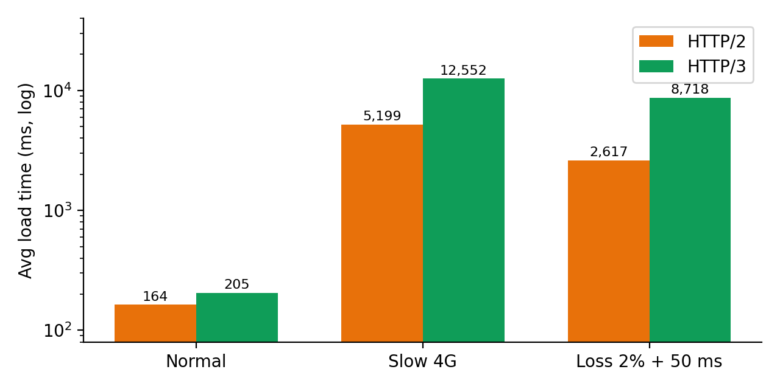
Analysis:
Key Observations: TTFB was similar in both normal and slow conditions (approximately 14 to 16 ms). HTTP/2 load times were faster in all three conditions: approximately 20% faster in normal networks, approximately 2.4 times faster in slow 4G, and approximately 3.3 times faster with packet loss. HTTP/3 results were more volatile (ranging from 8.6 to 14.6 seconds in slow 4G, while HTTP/2 remained between 5.19 and 5.21 seconds). TTFB also increased in the packet loss scenario to 160 to 220 ms due to the 50 ms latency added with each connection round.
When is HTTP/3 useful? On high-loss or volatile mobile networks, over long distances (high RTT) because the connection and encryption are performed in a single pass (sometimes 0-RTT), when a user switches between two networks (Wi-Fi to data) because QUIC supports connection relay, and on resource-intensive pages where actual packet loss is present.
When is it not useful? On fast, stable, low-loss networks (as in my experience with localhost), on small pages where setup costs are high, in environments that block or restrict UDP, causing the browser to revert to HTTP/2, and where the server or client processor has limited capacity.
Conclusion:
In my experience, HTTP/3 did not outperform in any of the three conditions, while HTTP/2 was faster and more stable. The results indicate that the advantages of HTTP/3 are dependent on real-world network conditions (packet loss, distance, mobility) not reflected in local testing, and that header blocking isolation alone is insufficient to offset the cost of QUIC. To strengthen this conclusion, it is recommended to increase the number of runs, test higher loss percentages (e.g., 5%), and test over a mobile network or a remote server.

